Eva: HUD’s HMIS Data Quality Tool
Iowa Balance of state continuum of care
Des Moines/Polk County Continuum of care

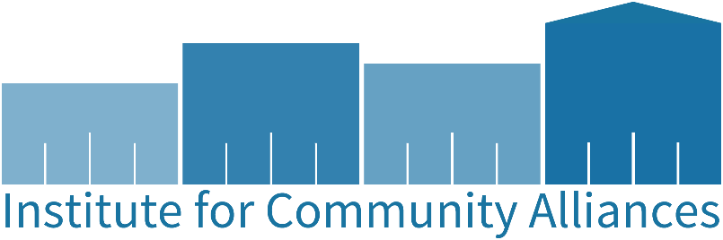

Institute for Community Alliances
1111 9th ST. #380, Des Moines, IA 50314
www.icalliances.org
Alaska | Boise city/Ada County | Iowa | Minnesota | Missouri | New Hampshire | North Dakota | Omaha/Council bluffs | Rockford/Dekalb Coalition | South Carolina | Vermont | Wisconsin | Wyoming

Version 1.0, updated 7/7/23
The HMIS tool Eva was created in 2022 by the Department of Housing and Urban Development (HUD) and the HUD Technical Assistance (HUD TA) agencies primarily to assist communities in preparation for required federal reporting, such as the System Performance Measures and the Longitudinal System Analysis.
In 2023, Wellsky updated their system to allow all users the ability to pull the report that is essential to be able to utilize Eva. Thus, this data quality tool can now be used by any individual at any level to check their project’s and organization’s data quality at any time.
This document walks through pulling the HMIS report from ServicePoint, how to upload this report to Eva, and how to utilize the results from Eva to complete corrections.
Contents
Pulling the HMIS-CSV Report from HMIS 4
Uploading Data into Eva 7
Navigating Eva 10
Organization-level Data Quality Page 13
Organization-level Data Quality Export 16

Pulling the HMIS-CSV Report from ServicePoint
Eva is a tool that exists outside of HMIS and DVIMS, and so users are required to pull a specific report in ServicePoint in order to utilize Eva.
This report is the Hashed HMIS CSV (it will have this name in DVIMS too), found on the Reports tab as shown in the highlighted yellow box in the screen shot below.
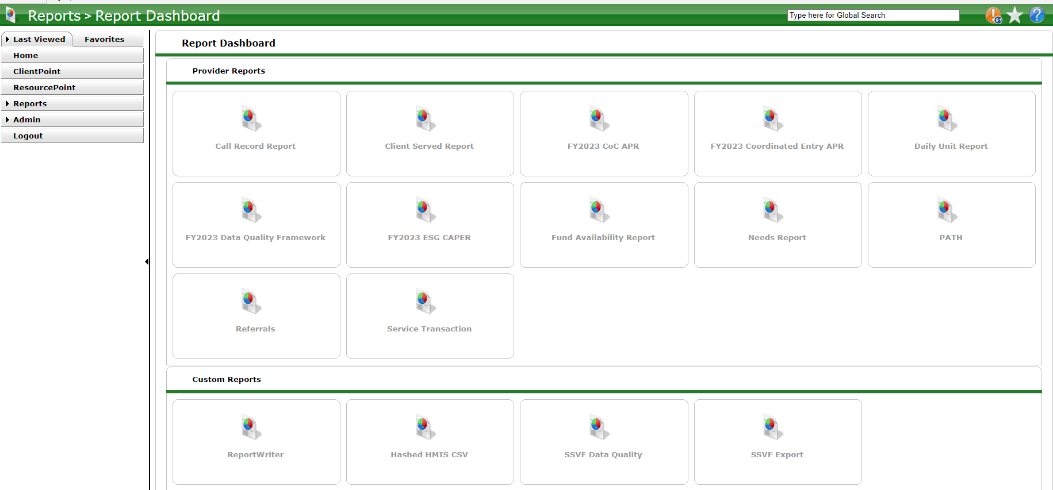
After clicking on the Hashed HMIS CSV, you will then click ‘Start New Export’, as seen in the screenshot below.
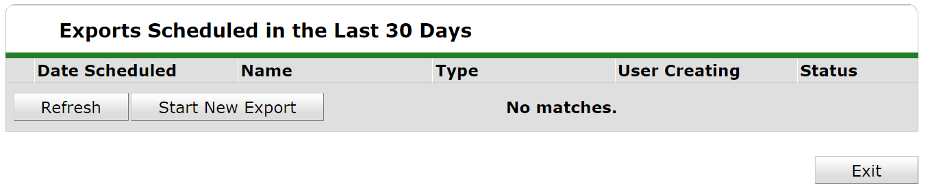
In the resulting menu, you will give the export a name, choose the project type(s) of the project(s) you’re interested in. For the ‘Provider Type’, in most instances you will want to choose a ‘Reporting Group’.
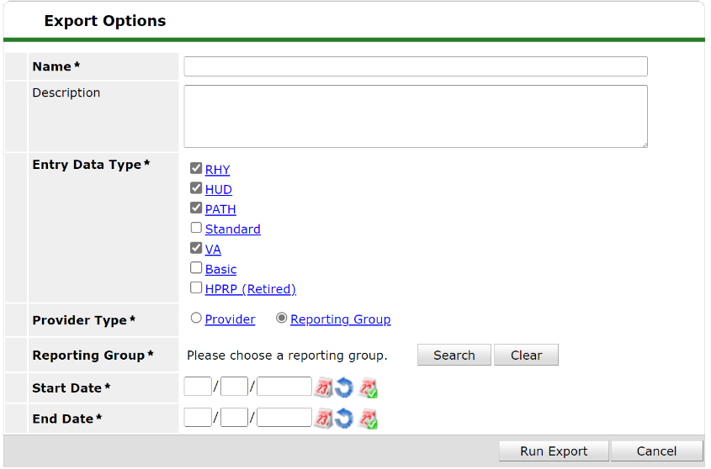
Reporting groups allow you to run this report to include information from multiple different projects. Once you select ‘Reporting Group’, you will then search for a group in the pop-out window that appears. Click on the green ‘plus’ sign to the left of the group you want to run this report for.
Note: Reporting Groups have to be created, edited, and deleted by a System Administrator. You can confirm the projects included in each reporting group by running the group in the a CoC-APR, ESG-CAPER, or Data Quality Framework report and looking at the projects listed in section 4a. If the project lists need to be edited in any way, please contact a system administrator.
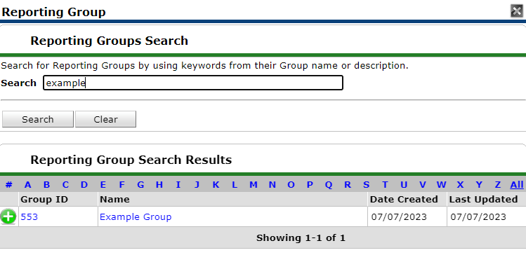
Once you have chosen the reporting group you’re interested in, you will then want to complete the reporting Start Date and the End Date. Then, click ‘Run Export’.
The export will then show under the scheduled export list, with a ‘Status’ showing ‘Pending’. It can take a little bit of time for these exports to complete, but rarely takes more than 10 minutes.
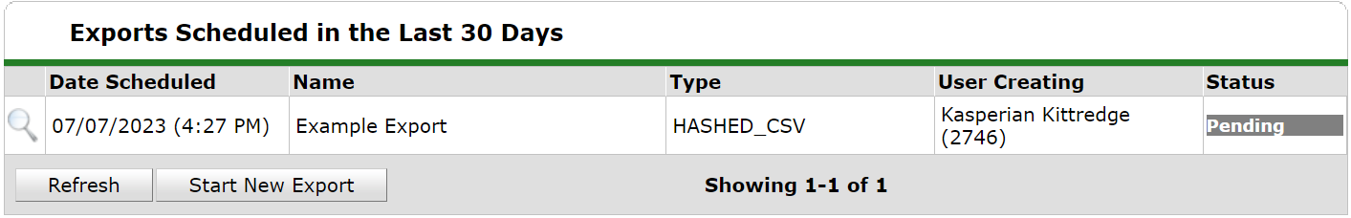
I sometimes click on the ‘Refresh’ button at the bottom of this menu intermittently to update the ‘Status’. Once the the ‘Status’ changes to ‘Completed’, click on the magnifying glass for the export.
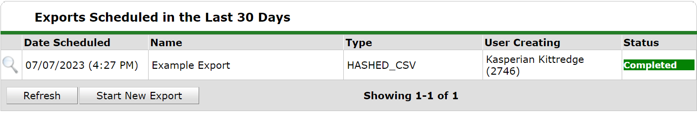

The pop-up window below will then appear. This window contains some meta data regarding the export, so that if you’re wanting to download this report again, you’re able to ensure that you’re downloading the correct version.
Click on the ‘Download Results’ button. This will download a zipped .csv file onto your computer. You can now move onto Eva!
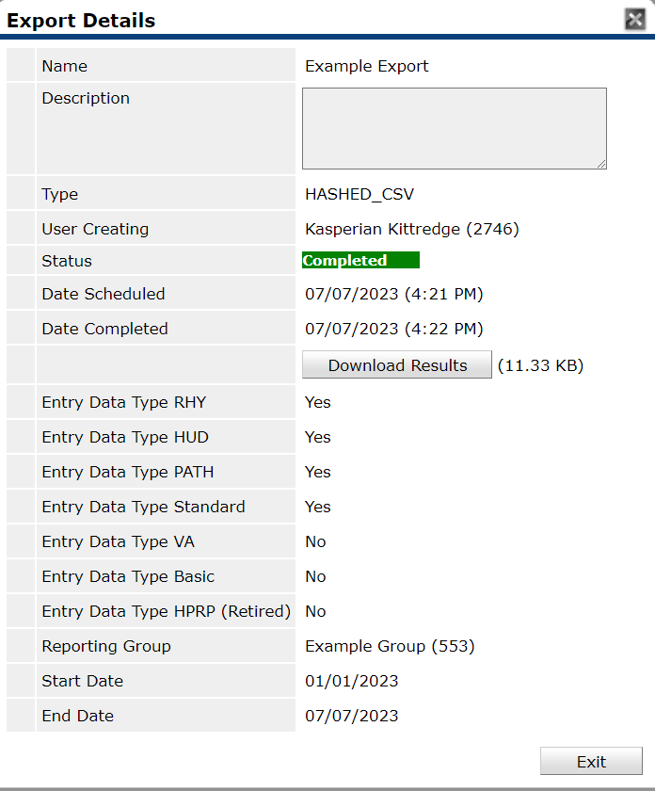

Uploading Data into Eva
You can access Eva at: https://hmis.abtsites.com/eva/
Eva is generally a very accessible site, intended to be user-friendly. The Home page welcomes you to the site, and walks you through uploading the Hashed HMIS-CSV export. Each tab on Eva’s menu (seen on the left-hand side of the site) has an ‘Instructions’ tab that can be opened and gives you details about what that tab contains and how to engage with it.
Some users will find it easier to follow Eva’s instructions. Other users may find it easier to follow the instructions in this document; if you fall in the latter category, please continue reading!
First, you will click on the ‘Click here to get started’ button. This will automatically move you to the ‘Upload HMIS CSV Export’ tab.
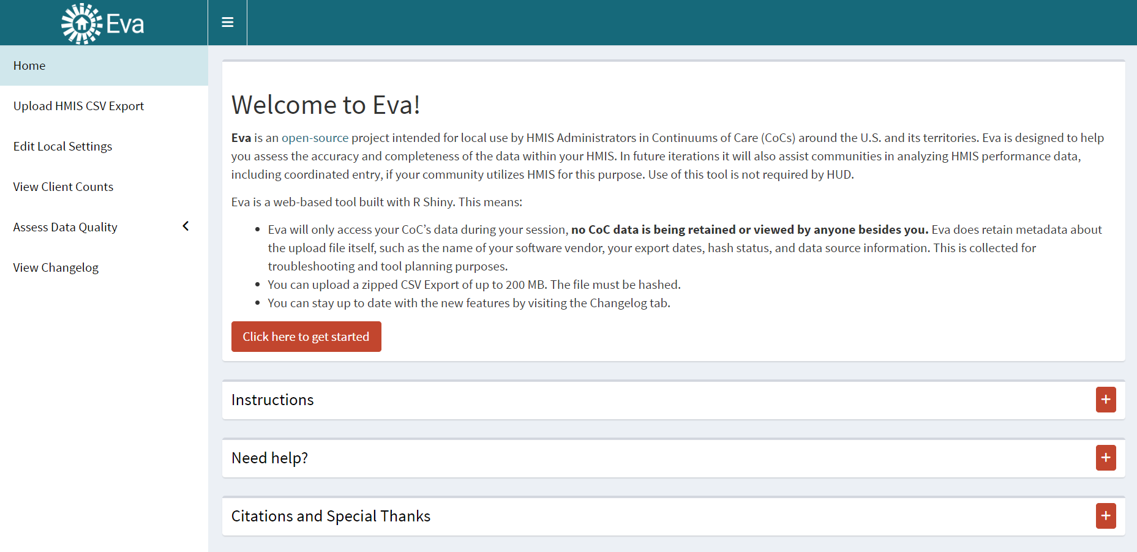
Then, you will click ‘Browse’ to select the zipped .csv export that you just downloaded from HMIS/DVIMS. Eva often takes several seconds to several minutes to process these exports, so don’t be alarmed if you don’t see any acceptance confirmation immediately.
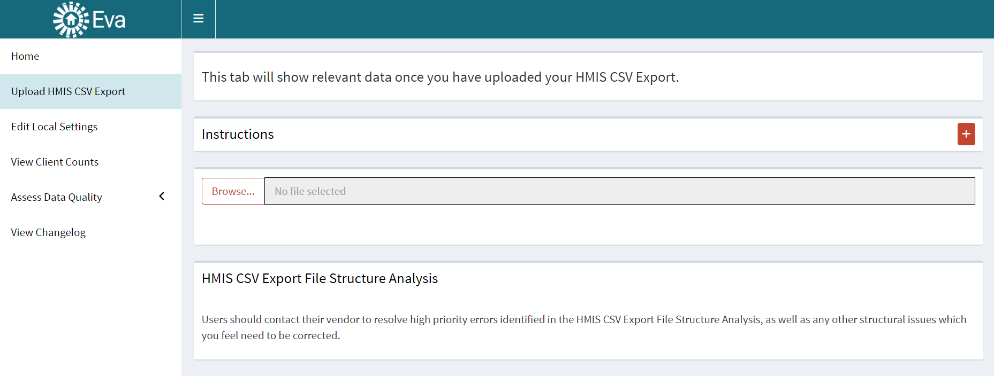
Occasionally your CSV Export will not be accepted. If this is the case for your export, you will see the following error message pop up:
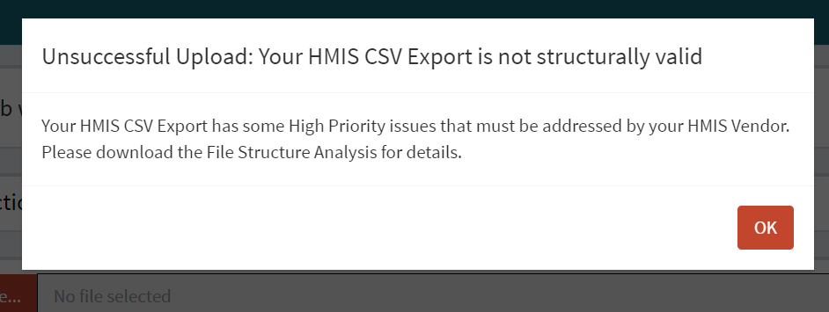
If you receive this error, click ‘OK’. Then, click the ‘Download Structure Analysis Detail’ button on the screen. This will download a .csv file that contains details regarding issues that are preventing a successful upload. Send both this .csv and the Hashed HMIS-CSV export files to a System Administrator, as often the errors need to be addressed by a System Administrator.
Note: Sometimes ‘Client Location’ errors will also result in a rejected upload. It’s advised that you first run your reporting group with the CoC-APR, ESG-CAPER, or Data Quality Framework reports first to identify and correct any ‘Client Location’ errors, found in section 6b.
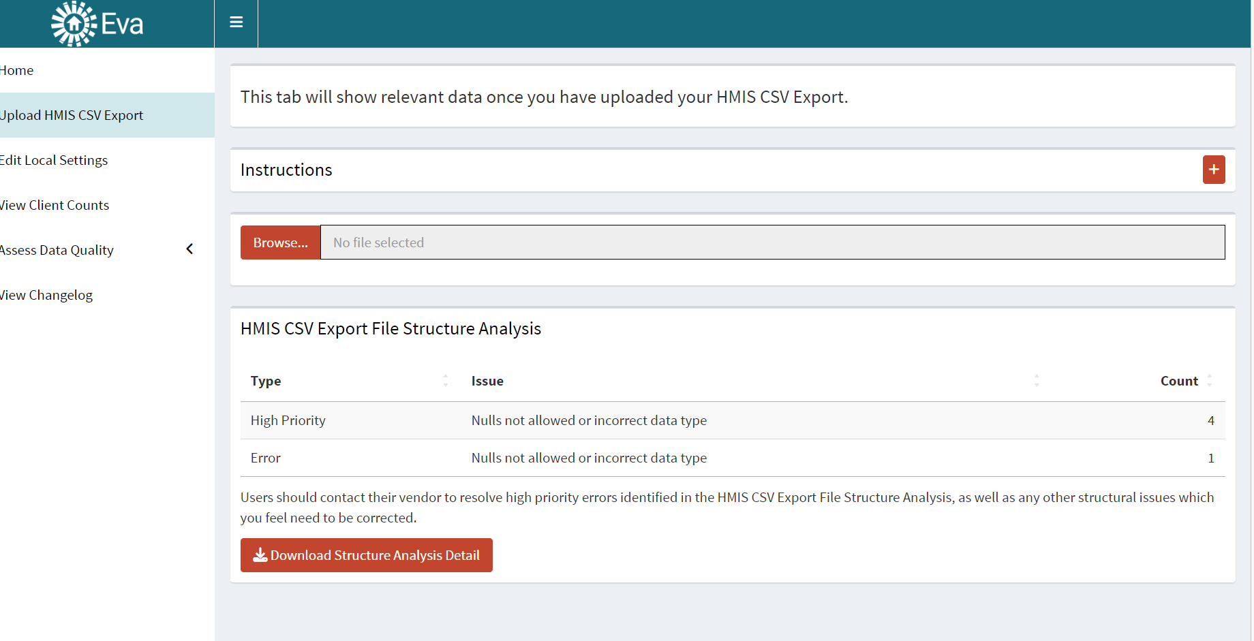

Eva will time-out after 10 minutes or so of no interaction, resulting in the error screen below. You will have to refresh the page and re-upload your Hashed HMIS-CSV export.
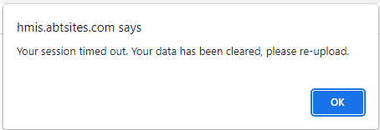
If your upload is successful, you’ll see the congratulatory message shown below. Click ‘OK’, and then proceed to Eva!
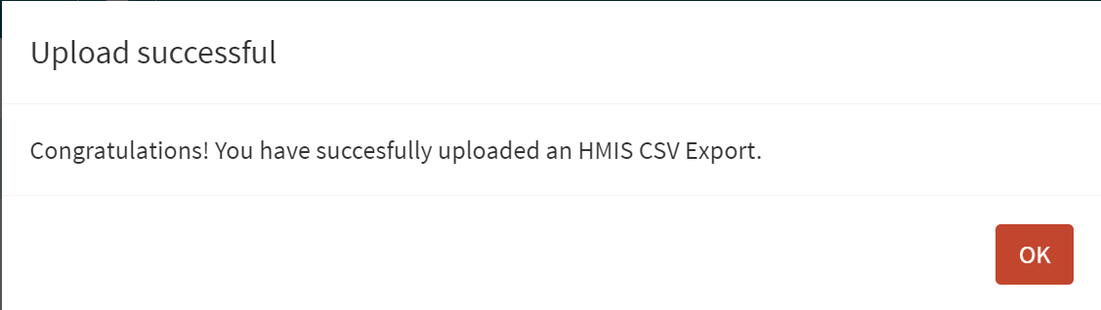

Navigating Eva
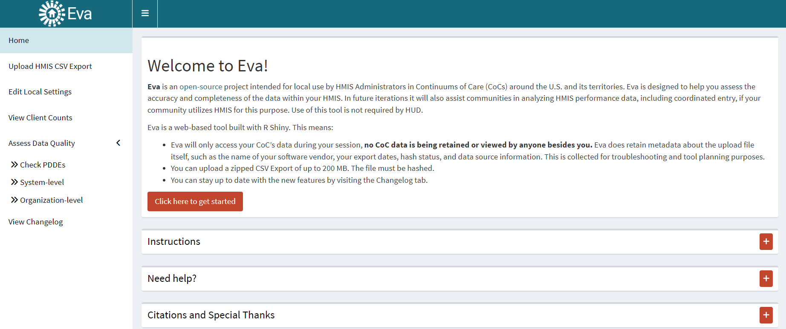
You can now navigate along the menu on the left-hand side of the screen.
Home – this is the home page shown in the screen shot above. It contains introductory information regarding how to utilize Eva.
Upload HMIS CSV Export – this page is where you upload the Hashed HMIS-CSV export. You can navigate to this page at any time if you want to replace the export with a new export.
Edit Local Settings – this page allows you to edit certain settings in Eva. The majority of these settings are related to the length of time clients are expected to remain in projects. For example, if you have an Emergency Shelter and want to limit the length of time clients are expected to remain in the project from 90 days to 30 days, then you can make those changes here. That change will then highlight clients who have been enrolled in your Emergency Shelter for more than 30 days, as opposed to the pre-set 90 days.
We will not cover this page further on this walk-through.
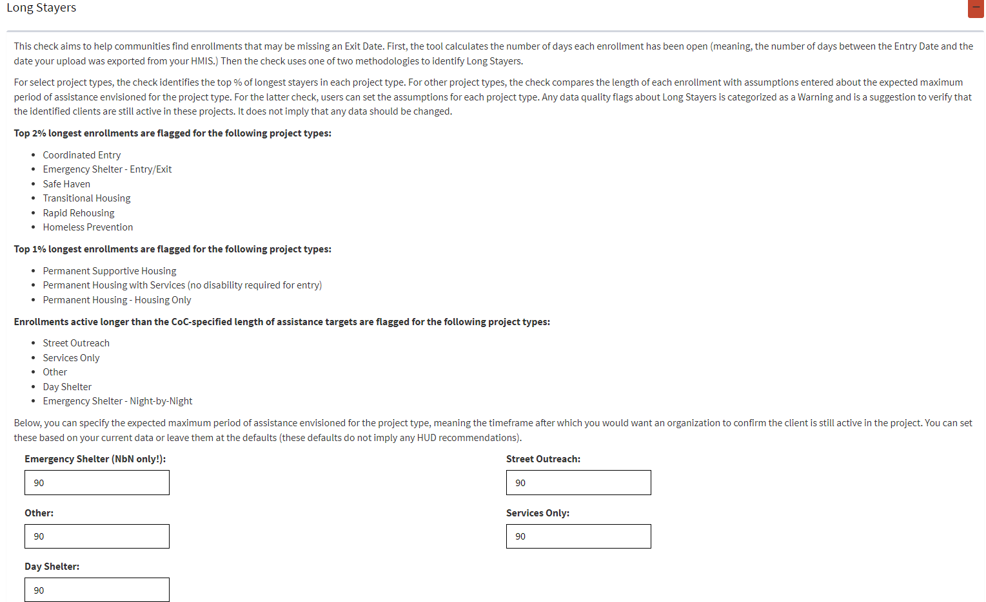
View Client Counts – this page contains total counts of clients enrolled in each project, which can be changed in the ‘Select Project’ section shown below. The ‘Date Range’ listed can also be changed as desired.
The ‘Client Counts Summary’ will provide slightly different status options depending on the project type. In the example below, you can see that move-in dates are incorporated, since the project selected is a Rapid Rehousing project; move-in dates are not incorporated for Emergency Shelter projects, on the other hand, since those project types don’t use move-in dates.
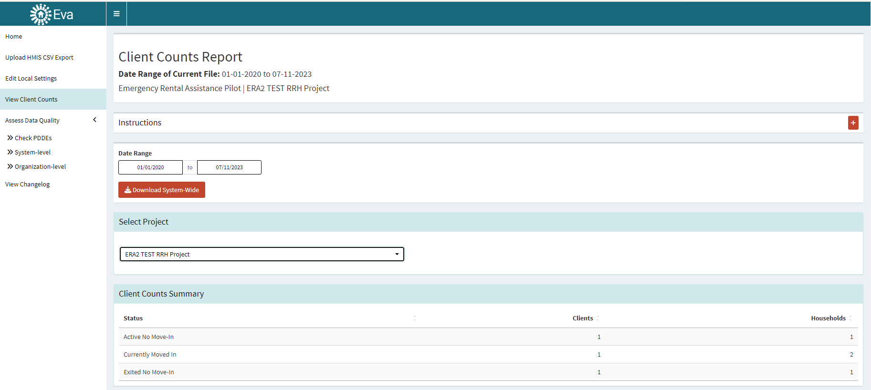
This page also contains a ‘Client Counts Detail’ section which includes client-level information regarding some data quality metrics, such as each client’s Relationship to Head of Household (HoH), their entry date, their move-in date (when applicable), their exit date, and their current active status as determined by Eva.
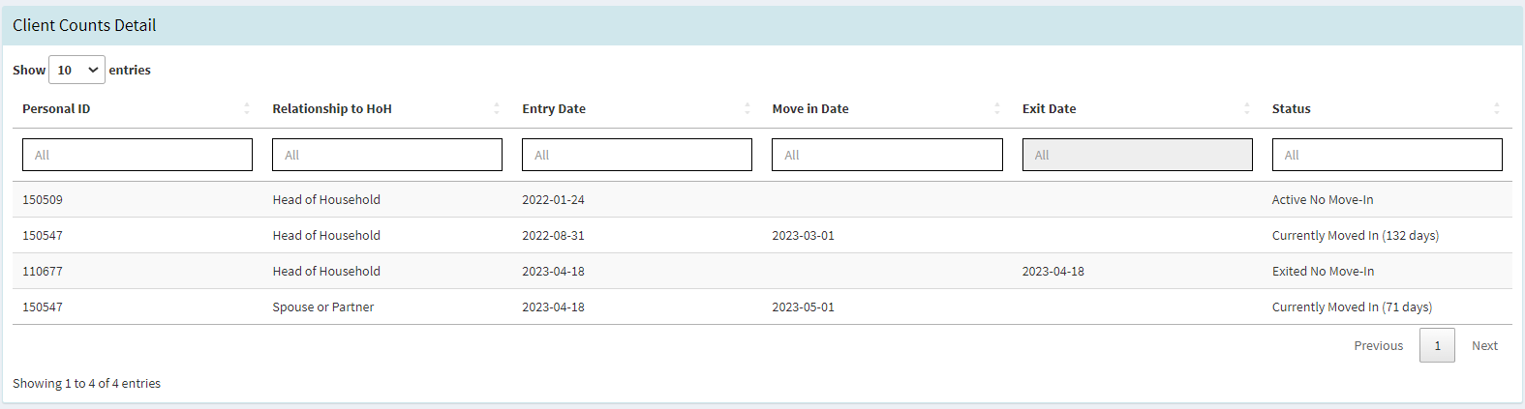
Note: unfortunately, the ‘Download System-Wide’ button was not working as of the production of this walkthrough. We will submit a query to the Eva development team regarding this issue.
Assess Data Quality – click on this section to access the pages below.
Check PDDEs – this page is primarily for System Administrators. Project Descriptor Data Elements (PDDEs) can only be updated or corrected by System Administrators. Although you can alert System Administrators of any errors or warnings that appear on this page, users cannot change or correct any of this information in HMIS/DVIMS themselves. Feel free to let System Administrators know whether there is anything that they should take note of!
System-level – this page provides a system-level overview of the errors and warnings across all organizations and projects included in the export. This page is most useful for System Administrators and CoC staff, since visibility settings do not allow users to access more than one organization’s information at a time.
Organization-level – this page is most useful for users. It provides organization-level and project-level information regarding data quality errors and warnings, as well as a detailed export that provides guidance on addressing these errors and warnings.
View Changelog – this page contains a record of updates and changes made to Eva.

Organization-level Data Quality Page
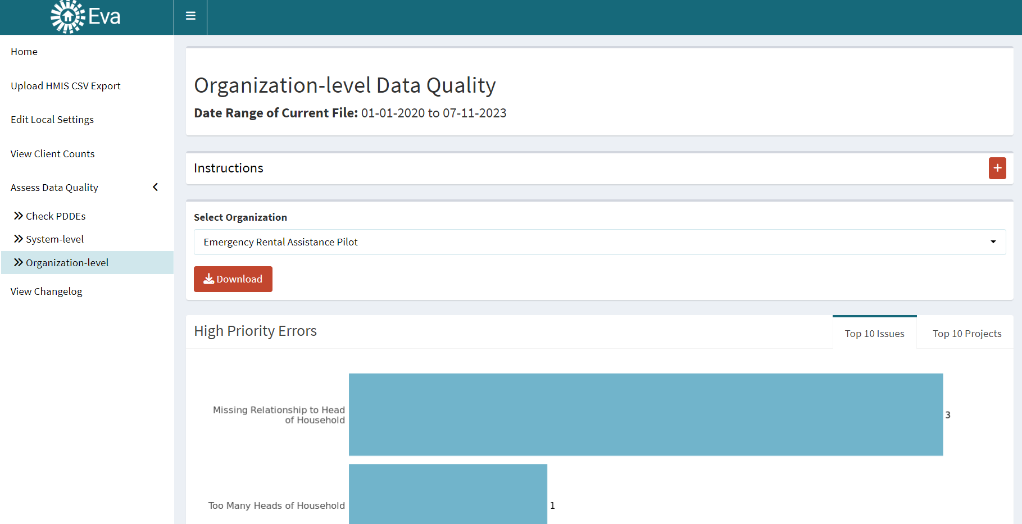
This page contains a plethora of data quality information for all of the projects included in the Hashed HMIS-CSV export. The data quality sections include:
High Priority Errors – these are errors that must be addressed to submit federal reports. These errors are Relationship to HoH errors (No HoH, Too Many HoH, or Missing Relationship to HoH) and identifies duplicate entries. Agencies should prioritize addressing these errors first.
If left unaddressed, System Administrators must correct these errors to submit federal reports such as the LSA, System Performance Measures, and the Point-in-Time.
General Errors – these are errors that should be corrected as they impact data quality on federal reports (but aren’t required to be corrected to submit federal reports). These include errors such as identifying clients with missing data, invalid move-in dates, and conflicting HUD Verification and tabular information. Agencies should prioritize addressing these errors to achieve accurate data.
Warnings – these should be reviewed, but do not necessarily need to be corrected. These identify clients who have “Don’t Know/Refused” answers, as well as identifying project overlaps (ie, entries into two different RRH projects at the same time), and clients who may have missed move-in or exit dates. Since there can be many warnings per organization, many of which may be accurate, agencies should prioritize addressing these by the type of issue identified.

In each of these data quality sections, users can choose to show either the Top 10 Issues (seen in the screenshot on the previous page), or the Top 10 Projects (seen in the screenshot below). This allows organizations to quickly assess which issues are most prevalent across their organization, and which projects are connected to the most issues.
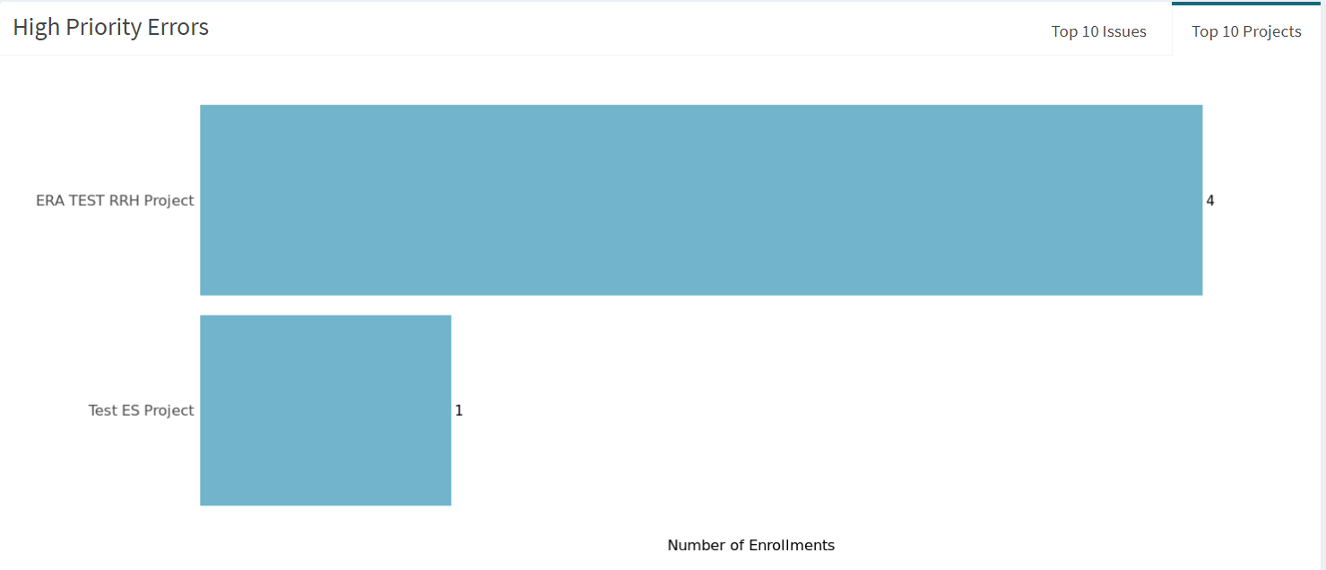
After the Errors and Warnings sections, the Data Quality Summary section includes a list of the issues that the organization possesses. This summary information can be filtered by the project name, error/warning type, the exact issue, and the number of clients affected.
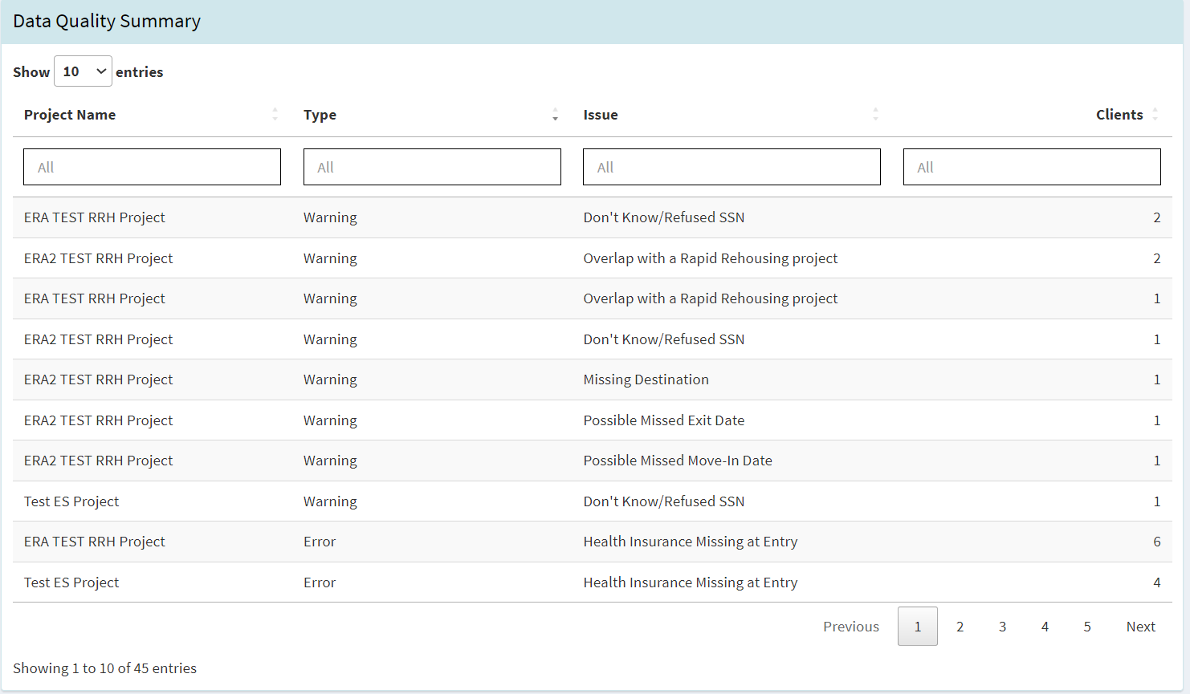
At the bottom of the page is the ‘Data Quality Guidance’ section. This provides guidance on how to address each of the types of errors and warnings listed for the organization.
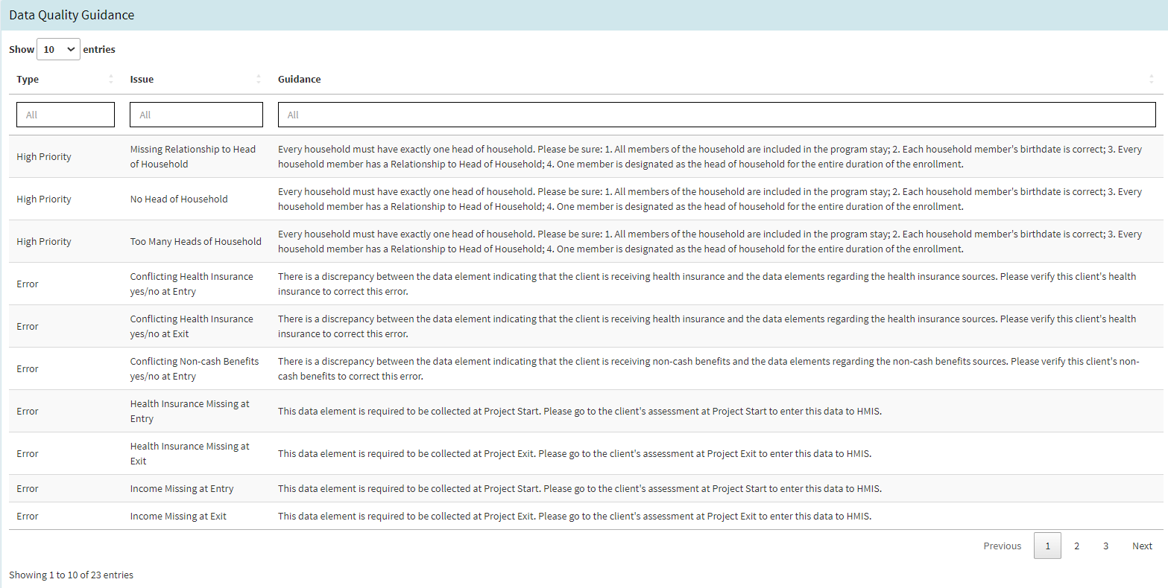
Note: not all errors and warnings will appear for all exports. Only the errors and warnings that apply to the organizational information will be shown.

Organization-level Data Quality Export
It’s great to see how an organization’s projects are doing, but how do we identify the clients that these errors and warnings apply to? That’s where the Organization-Level Data Quality Export comes in!
At the top of the Organization-level Data Quality page, click on the ‘Download’ button.
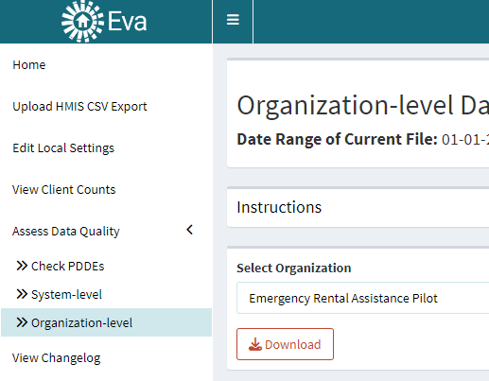
This will export a .csv file with 8 tabs. Those tabs are:
Export Detail – this tab contains two columns of information regarding the start date and end date that the Hashed HMIS-CSV export was run, as well as the date that the export was created.
Organization Summary – this tab contains a list of the errors and warnings throughout the organization, with a count of the number of enrollments pertaining to each issue. This is useful to see which issues are affecting the entire organization the most at a glance.
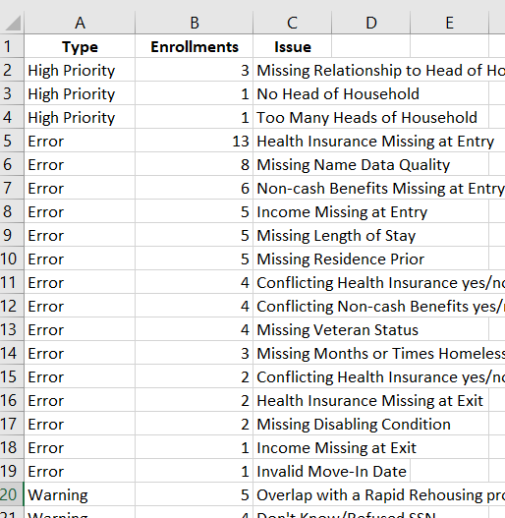
Project Summary – this tab contains a list of the types of errors and exact issues pertaining to each individual project within an organization. This is useful for identifying how many issues pertain to each individual project at a glance.
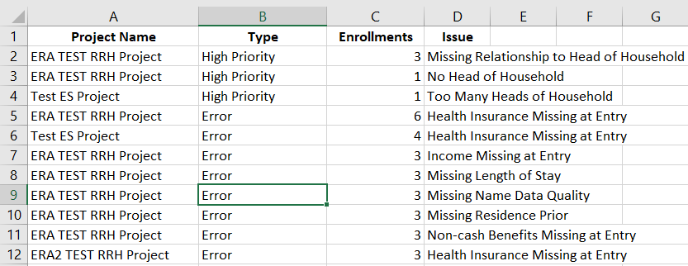
Guidance – this tab contains a reference to each issue listed in the .csv file, with guidance on how to start addressing each issue. This guidance can be very helpful with assisting users who are familiar with ServicePoint to solving the issues; newer users may need additional assistance from other resources to completely resolve these issues. Please contact a System Administrator if you need additional direction!
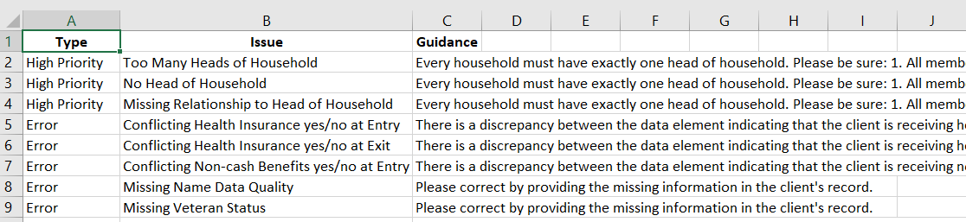
High Priority – this tab contains only the high priority errors for the organization. It contains the Project Name, the client’s ID, and the Entry Date that are connected each issue. This allows projects to identify the exact enrollment for each client that is causing the issue, and then to correct those issues.
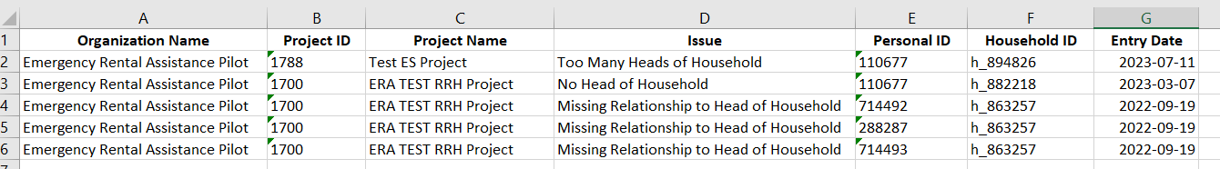
Errors – this tab contains the same information as the High Priority tab, but in regard to General Errors.
Warnings – this tab contains the same information as the High Priority tab, but in regard to Warnings.
Overlap Details – this tab contains detailed information regarding any concerning project overlaps, such as a client enrolled in two Emergency Shelters or two Rapid Rehousing projects at the same time. This tab is most helpful to System Administrators, but may be useful for users to help identify inaccurate overlaps of projects, too.
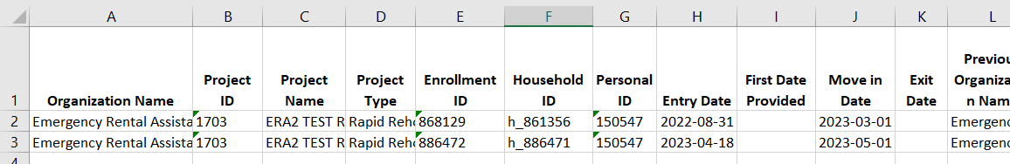

These align with the project type you choose when first creating an enrollment for a client. When in doubt, choose ‘HUD’. There is no negative consequence if you choose more project types than the data you’re pulling this report for.

